**DYNAMIC RISK SPILLOVERS FROM OIL TO STOCK MARKETS AMONG THE EMERGING ECONOMIES:**

*EVIDENCE FROM A*

*GARCH COPULA QUANTILE REGRESSION-BASED CoVar MODEL*

In Partial Fulfillment of the FINANCIAL RISK ANALYSIS AND MANAGEMENT - FIN F414 Course.

SUBMITTED TO **MR. ASHWINI KUMAR MISHRA**



**BITS PILANI**

K K BIRLA GOA CAMPUS

**Team Members:**

Akshat Sandeep Goel(2020B3A70283G)

Deeptanshu Prakash(2020B3A71840G)

Anish S Kamath(2020B3A71085G)

Alben D’Souza(2020B3A71833G)

Anushka Nair(2020B5A41624G)

Highlights:

* Estimation of returns spillover among emerging economies using GARCH Copula Quantile Regression-based CoVar model analysis.
* Focus on the impact of oil market fluctuations on stock markets for examination of economic events, geopolitical conflicts, and energy market volatility.
* Significant findings on the influence of COVID-19 pandemic and housing crisis of 2008.
* Insights into complexities of investment strategies and implications for effective supervisory policies.

TABLE OF CONTENTS

**ABSTRACT 3**

1. INTRODUCTION 4

2. METHODOLOGY 6

2.1 CoVaR model 6

2.2 Marginal distribution model 7

2.3 CQR model 8

2.4 GARCH CQR-based UCoVaR model 12

**3. DATA 14**

4. RESULTS & DISCUSSION 15

4.1 Marginal Distribution’s Estimates 15

4.2 Propagation of Dynamic Risks from Oil to Stock Markets 21

4.3 Results and Inference 24

**5. CONCLUSION 26**

5.1 Brent Oil vs the Countries 26

5.2 From Graph 26

**6. APPENDIX 28**

**7. REFERENCES 30**

### ABSTRACT

This research investigates risk spillovers from dependence between Brent Crude oil and stock markets in six emerging nations (Brazil, China, India, Indonesia, South Korea, and Mexico) using daily MSCI indices data from January 2001 to December 2022. Employing graphical and statistical analyses, the study reveals notable correlations between oil and stock market trends during major global events. The research uses ARMA-GARCH models to estimate marginal distributions, identifying the ARMA(1,1)- EGARCH(1,1). The study then explores nonlinear relationships through copula functions, revealing the asymmetric nature of risk spillovers.

The empirical results of risk spillover analysis from Brent Crude oil to six emerging economies indicate that the Indian and Indonesian stock markets experience the highest downside and upside risk impacts, respectively. However, in contrast, the Mexican stock market displayed the least risk spillovers, showcasing a non-symmetric pattern that aligned with flight-to-quality dynamics. Additionally, our findings highlight temporal heterogeneity in dynamic risk spillover effects.

Our findings have crucial implications for international investors and supervisory authorities seeking to optimize investment strategies and develop effective policy responses in light of evolving risk spillover dynamics.

*Keywords:*

Risk Spillover, Stock Market Volatility, Emerging Economies, CoVar, Geopolitical Events, Oil Market

***JEL classifications:***

***C58***

***G14***

***G15***

***Q43***

### 1. INTRODUCTION

Any nation's economic stability highly depends on the country's energy supply in modern society. Since the outbreak of the COVID-19 epidemic in 2020, there has been a period of global economic decline. Low demands have caused multiple production-line shutdowns, causing a significant decline in energy demand and prices. The Russia-Ukraine conflict, on the other hand, has led to a sharp rise in energy prices (Gong et al., 2023). Despite the increased usage of renewable energy, 83.1% of energy consumption in 2020 was derived from fossil fuels, according to BP's 2021 report(British Petroleum, 2022), and petroleum continues to account for the most significant portion of the energy consumption structure.

The phrase "spillover of shocks" has increased, especially after the 2008 financial crisis. Therefore, it is crucial to understand the concept of "spillover". Our report interchangeably uses spillover, co-movement, contagion, and co-integration(Khan et al., 2023). The World Bank defines contagion as a significant increase in cross-market links following a disruption to a single country (or group of countries). This is determined by comparing the degree to which asset prices or financial flows move across markets in tandem with each other during periods of relative calm. Due to liquidity restrictions, investors are forced to remove money from other nations when a crisis arises in one. (Richard N. Cooper, n.d.).

Stock prices can be impacted by oil price shocks through a number of different economic pathways. First, rising crude prices lead to inflation and lower economic spending, which in turn fuels job losses and dims prospects for future growth in the economy. The ensuing recession may be detrimental to the stock market. (Rasche & Tatom, 1977).

Secondly, an increase in the price of commodities caused by a rise in oil prices reduces the profits of companies highly dependent on oil and energy, resulting in a decline in their stock prices. The inflation impact is the term for this course. Furthermore, when consumers bear a greater amount of the burden of the rising oil prices, their cost of living and money demand also climb. The real balance effect refers to the drop in the stock price that occurs when there is no change in the money supply because the short-term interest rate will rise, raising the financing costs for the company and the discount rate on future earnings. (Bernanke et al., 1997).

Third, The movement of purchasing power from oil-importing to oil-exporting nations is how rising oil prices affect stock prices and economic activity. The phrase "income transfers and aggregate demand" refers to this phenomenon. The increase in oil prices results in a fall in oil-importing nations' stock prices while increasing oil-exporting countries' stock prices (Abbott, 2007).

The fourth channel, the uncertainty effect, is caused by the increased volatility of oil prices, which can impact actual economic activity and stock prices(Bernanke, 1983).

Although GARCH copula quantile regression-based CoVaR models are a sophisticated framework for understanding spillover effects, emerging economies still need research. Many studies have focused on only developed economies and select developing countries(Tian et al., 2022) (Jones & Kaul, 1996). Hence, a significant gap exists in understanding how these models perform in emerging markets.

Most existing studies have assumed a linear relationship in their models. This ignores the non-linear dynamics of commodity markets. Investigating the non-linear relationships through copula modelling can provide a more accurate representation of cross-market spillover effects (B. & Paul, 2021).

Our primary benchmark, Brent Crude Oil, is named after the North Sea Brent oil field. It represents a category of crude oil that is "light sweet" due to its low density and sulfur content. This makes it ideal for refining into valuable products like gasoline. Brent Crude is critical in setting global oil prices, traded on the Intercontinental Exchange (ICE), and referenced in approximately two-thirds of internationally traded crude oil. Its prices are closely monitored, significantly impacting the global economy and influencing energy costs for consumers and businesses. It is subject to volatility caused due to common factors such as geopolitical events and supply and demand dynamics (Barbaglia et al., 2020). Our research contributes to the preset literature in the following ways: First, we have used the oil-stock price relationship in a novel CoVaR model based on the recently developed GARCH CQR model by Tian and Ji (2022). We have used this analysis to find the positive tail dependence between the oil and stock markets at varying risk levels. Seven distinct copulas are modelled to evaluate the non-linear relationships in both the downside and upside-tail dependence, with the marginal distributions being established using the GARCH family of models. The GARCH CQR model has substantially enhanced our understanding of the spillovers from the energy and stock markets. Based on our results, we have also provided suggestions for policy-makers and international investors (Tian et al., 2022)

Secondly, unlike previous studies, we have used an expanded dataset from January 1, 2001, to December 29, 2022, with 5745 daily observations. Using this data, we aim to capture the effects of COVID-19 from 2020-2021 and, after that, the ongoing Russia-Ukraine War.

Finally, we have analysed six emerging economic nations that have not been explored before(China, India, Brazil, South Korea, Mexico, and Indonesia). Countries experiencing rapid economic growth and development are mostly called emerging economies. They have transitioned from agrarian to industrialised economies, are currently opening up to foreign investment, and may undergo rampant political and regulatory changes to attract capital and promote stability. Emerging economies can be separated from other nations due to their standard features like investment in infrastructure, urbanisation, and the rise of the middle class. While they offer growth opportunities, they also carry the risk of political instability and currency volatility (Basher & Sadorsky, 2006).

### 2. METHODOLOGY

The upside-tail dependence is well captured by a GARCH CQR model. Thus, the GARCH CQR-based DCoVaR and UCoVaR models are used to calculate the downside and upside CoVaR and risk spillovers, respectively.

#### *2.1 CoVaR model*

For the purpose of estimating the risk spillovers from the crude oil market to the stock market, we employ the risk measure ΔCoVaR. First assessment: VaR. For a stock market ⅈ, the downside and upside at a confidence level are defined as:

The confidence level means that the probability of the maximum possible loss greater than the VaR is less than or equal to . It is clear that the risk measure VaR is correlated with downside risk (upside risk) for a portfolio firm holding a long position (a short position).

According to the VaR measure, the CoVaR measure (Adrian and Brunnermeier, 2016) is defined as follows. Given confidence level (1 - 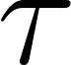 ), the downside and upside for the stock market , conditional on the downside and upside , for the returns of the oil market ⅈ at the confidence level satisfy

Here, and are the returns of oil markets ⅈ and stock market , respectively. Therefore, the risk spillover effect of one oil market  on the stock market  at confidence level can be defined as follows,

where and are the VaR of the stock market S conditional on the oil market  being in a distress state and a benchmark state, respectively.

Similarly, the upside risk spillover effect can be calculated by the following equation:

Tian and Ji (2022) have proposed using the GARCH CQR-based DCoVaR model to estimate the spillover of downside risk. We will derive the GARCH CQR-based UCoVaR model in the ensuing subsections.

#### *2.2 Marginal distribution model*

The most popular method for characterising the characteristics of serial correlations, volatility clustering, and conditional heteroskedasticity of financial returns is the ARMA-GARCH model, which we discuss in this part. The ARMA(p,q)-GARCH(m,s) model is typically built like this:

Where and are nonnegative integers and and are the

autoregressive and moving average parameters, respectively. is the conditional variance that has dynamics as given by the GARCH model:

where is a sequence of i.i.d. random variables with mean 0 and variance 1 and with

and

The following proposal for the EGARCH model (Nelson, 1991) accounts for asymmetric impacts between positive and negative asset returns:

where again is a sequence of i.i.d. random variables with mean 0 and variance 1, and

Clearly,

,

where is the expected value of absolute standardized innovation .

Denoting the asymmetry of the volatility for positive and negative returns, which is typically attributed to the leverage effect of equity returns, the parameter therefore captures the sign effect and the magnitude effect.

Following a standardised skew, the standardised residuals typically show the traits of kurtosis and skewness. The distribution of students' t (SSST).(Tsay, 2012). The data of residuals is in an attached excel sheet in subsection containing code files and data files. Let be the SSST distribution, and its PDF (probability density function) is

where is the PDF of the standardized Student’s distribution (SST):

where is the gamma function and is the degree of freedom. is equal to the ratio of probability masses above and below the mode of the distribution; hence, is the skewness parameter, , and .

#### *2.3 CQR model*

Let the cumulative distribution functions (CDFs) be and , respectively. They can be connected by the copula function , ) with parameter and we can get the joint distribution function , (Sklar, 1959). The bivariate one-parameter copula families given in Joe (1997) include B1 (Normal copula), B2 (Plackett copula), B3 (Frank copula), B4 (Clayton copula), B5 (Joe copula), B6 (Gumbel copula), B7 (Galambos copula), B8 (Hüsler-Reiss copula), B9 (Raftery copula), B10 (Morgenstern copula), B11 and B12. However, B1, B2,B3 and B10 cannot capture the property of asymmetric tail dependence, moreover the function of B9, B11 and B12 are complicated and non-differentiable. The Joe copula, Gumbel copula, Galambos copula, and Hüsler-Reiss copula are the other four copulas that can capture upside tail reliance structure, while the Clayton copula may depict downside tail dependence structure. To reflect the nonlinearity and asymmetry of the tail dependency structure, these five copulas and their 180-degree rotated counterparts (Joe, 1997; Nelsen, 2006) are chosen for this investigation and are displayed in Table 1.

Based on the definition of conditional CDF H(yx)



where is conditional copula. The conditional copula functions of the copula families shown in Table 1 are presented in Table 2. Fixing the conditional probability of given at quantile ; we can get

by solving for . Eq. (7) presents the copula quantile curve for .

Considering and , Eq. (7) can be rewritten as

Therefore, we can get the CQR function for at quantile as follows

*Table 1: Copula models.*

| Copula models | | | Copula function | Parameter | | |
| --- | --- | --- | --- | --- | --- | --- |
| Clayton | |  | | | |  | | |
| Rotated Clayton | |  | | | |  | | |
| Joe | |  | | | |  | | |
| Rotated Joe |  | | | |  | | |
| Gumbel |  | | | |  | | |
| Rotated Gumbel |  | | | |  | | |
| Galambos |  | | | |  | | |
| Rotated Galambos |  | | | |  | | |
| Hüsler-Reiss |  | | | |  | | |
| Rotated Hüsler- Reiss |  | | | |  | | |

*Note: is the CDF of standard normal distribution, where is the quantile function.*

Similarly, based on the definition of upside CoVaR, for the conditional quantile of given , we have

or .

Solving for yields the CQR curve for as the following equation:

Therefore, the CQR function for at quantile is



*Table 2: Conditional distributions of copula models.*

| Copula models | Conditional distribution functions |
| --- | --- |
| Clayton |  |
| Rotated Clayton |  |
| Joe |  |
| Rotated Joe |  |
| Gumbel |  |
| Rotated Gumbel |  |
| Galambos |  |
| Rotated |  |
| Galambos |  |
|  |  |
| Hüsler-Reiss |  |
| Rotated Hüsler- |  |
| Reiss |  |

Among all the above-mentioned copulas presented in Tables 1 and 2, Clayton copula, rotated copulas of Joe, Gumbel, Galambos and HüslerReiss can describe downside tail dependence and upside tail independence. In contrast, the rotated Clayton copula, Joe copula, Gumbel copula, Galambos copula and Hüsler-Reiss copula can capture upside tail dependence and downside tail independence. Thus, the corresponding CQR function could properly describe the lower or upper tail dependence between random variables or . To illustrate this desirable property, we generate 2000 random values of for different copula with different parameters , and the marginal distributions of and follow the SSST distribution with different parameters. We plot the CQR curves for ten copula families in Appendix A displaying different tail dependence behaviour.

#### *2.4 GARCH CQR-based UCoVaR model*

and denote the CDFs of and , returns of oil market and stock market , respectively. Thus, according to the definition of upside CoVaR and Eq. (10), we have

or

where and denote the CDFs of and , the standardized residuals of and and are the conditional mean and standard deviation of the returns of oil market and stock market , estimated by Eqs. (3), (4) or (5).

According to Eqs. (11) and (12), Eq. (14) is equivalent to

Therefore, the upside CoVaR can be estimated by

or

where is the quantile function of . Following Tian and Ji (2022), we can estimate the parameter in Eq. (17) by interior point algorithm for nonlinear quantile regression model (Koenker and Park, 1996) at the quantile:

based on , where is the conditional quantile of given is the zooming parameter and is the panning parameter.

Therefore, given confidence levels and , the upside CoVaR of the stock market conditional on the upside value at risk of the oil market being can be obtained as follows:

Eq. (19) is the GARCH CQR-based UCoVaR model. Meanwhile, the following equation is the GARCH CQR-based DCoVaR model (Tian and Ji, 2022):

In particular, the upside and downside CoVaRs of the stock market conditional on oil market being in its benchmark state can also be calculated by Eqs. (19) and (20), respectively. Therefore, the downward and upward risk spillover effects are determined by

and

When calculating the upside risk spillover effect using Eq. (19), the copula function should be chosen from the rotated Clayton copula, Gumbel copula, Joe copula, Hüsler-Reiss copula, and Galambos copula, which can describe the lower tail independence and upper tail dependence between financial returns. When it comes to downside risk spillovers, the copula function in Eq. (20) is the best of the Clayton copula, rotated copulas of Gumbel, Joe, HüslerReiss, and Galambos, and can represent upper tail independence and lower tail reliance. Moreover, the GARCH CQR model has the following two advantages over other comparable methods: first, it can precisely capture the characteristics of serial correlation and volatility clustering of the returns on financial assets; second, it can characterise the nonlinearity of the upside and downside tail dependence structure between the stock market and oil returns at different risk levels.

### 3. DATA

Examining risk spillovers from the Brent Crude oil market and WTI oil market to six nations' stock markets - Brazil, China, India, Indonesia, South Korea and Mexico: we selected daily data of MSCI indices. These were chosen as a representation for the stock market indices–from January 1st, 2001 through December 31st, 2022 (a total of 5739 observations). In addition to this dataset acquisition—Bloomberg terminal provided us with Brent Crude oil prices' collection.

We initially graphed the basic daily closing prices of the index against each country's daily oil market closure. This step illuminated long-term trends in MSCI price indices and Brent Crude oil prices over our analyzed period; moreover, it became evident that significant fluctuations among all eight price indices are relatively similar. Figure 2 typically illustrates a drastic downward trend of the eleven price indices following severe risk events such as: the European debt crisis, global financial crisis, COVID-19 pandemic and Russia-Ukraine conflict; this implies a notable correlation between these events and substantial market downturns.

We then graphed each index's log returns alongside those of the Brent Crude oil market. A similar volatility clustering occurs about this specific period, yet responses to the shocks differ across diverse financial markets (see Figure 3).

Each country's oil and index returns exhibit a nonlinear relationship in the scatter plots, specifically within their upper and lower tails; this implies the necessity of employing a nonlinear model to scrutinize risk spillover effects from the oil market onto stock markets.

Finally, we employed descriptive statistics for a numerical analysis of the trend. The table incorporates: mean, maxima and minima; median; skewness; standard deviation - also known as volatility - and kurtosis.

Saudi Arabia's and Kuwait's data was found to be of a much lesser time period, thus both were excluded from this study after severe discussions. WTI data was giving errors while plotting the final CoVaR graphs, hence it was omitted at the last minute. WTI is produced in the US, hence it may not have that much impact in countries as it is not that widespread as compared to Brent Crude.

### 4. RESULTS & DISCUSSION

#### *4.1 Marginal Distribution’s Estimates*

As seen in the previous section, we use the ARMA-GARCH family models as the foundation for distribution properties like skewness, volatility clustering, heavy tails and marginal distributions of Stock and Oil market returns. The ARMA-GARCH models are used in conjunction with standard normal distribution and SSST distribution, respectively.

Upon applying the Ljung-Box test to the ARMA(1,1)-EGARCH(1,1)’s standardized residuals (with SSST), we see that the null hypothesis of autocorrelation is accepted at 5% significance level and a lag of 20.

The absence of ARCH effects at 5% significance in the return series is shown with the help of Engle’s LM test. As seen from the high kurtosis values in table 3, the estimates of the SST distribution’s parameter suggest that the standardized residuals do not follow normal distribution. Furthermore, the ARMA(1,1)-EGARCH(1,1) model’s adequacy is also depicted with the help of standard deviations and parameter estimates.

Throughout the analyzed period, Figure 1 depicts trends of Brent Oil and MSCI indices’ prices. Notably, the price indices exhibit substantial similarity in their fluctuations. Specifically, extreme risk events, like the 2008 Lehman crisis, the European debt crisis, and the COVID-19 pandemic, resulted in a notable downward trend in the price indices.

China India

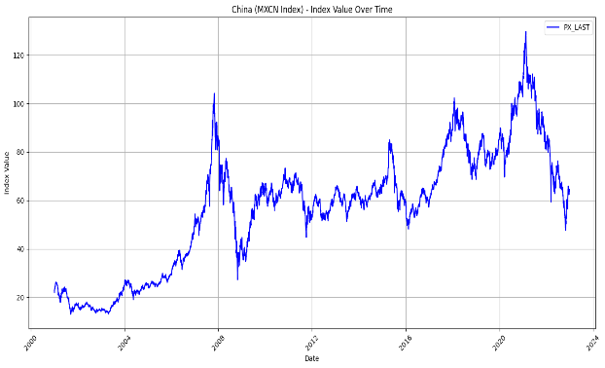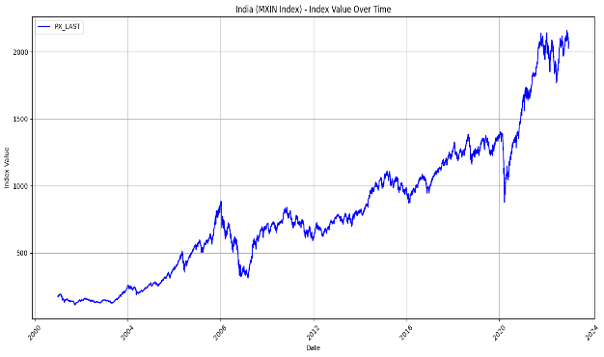

Indonesia                                                       South Korea

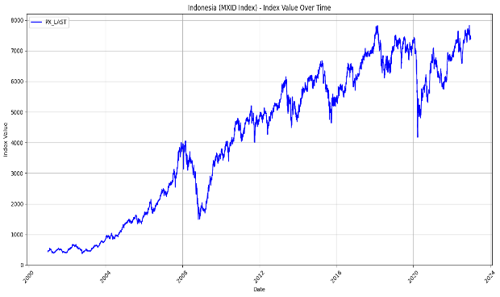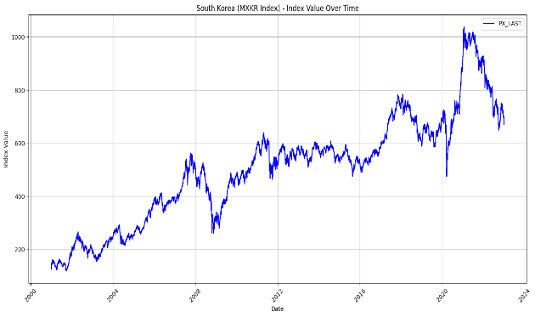

Mexico Brazil

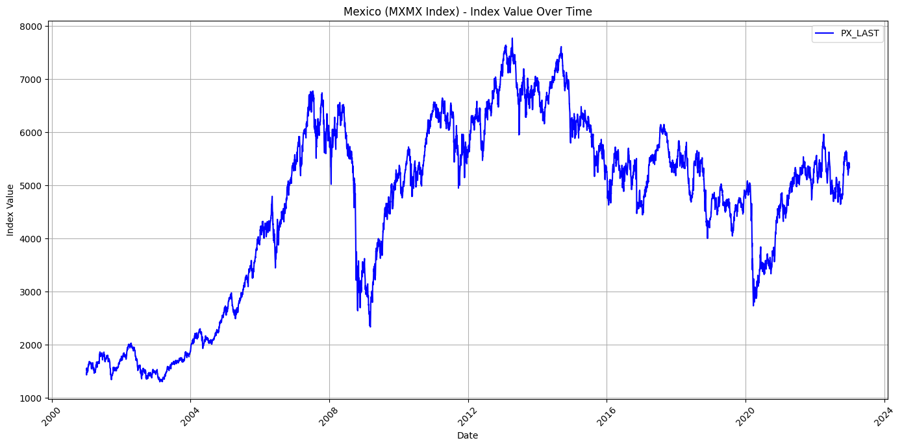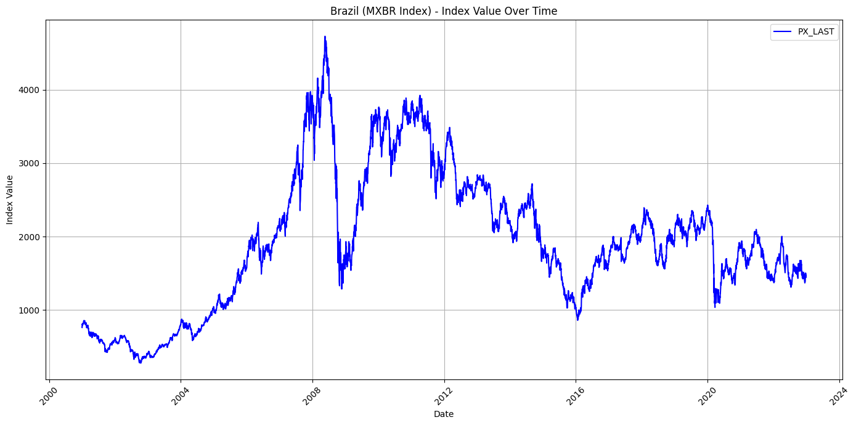

Brent Oil

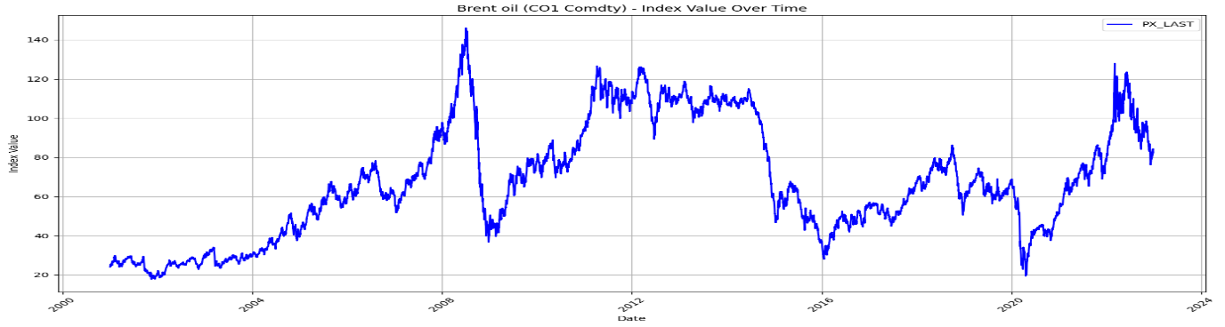

*Fig. 1. MSCI Indices of different Oil Markets*

In Fig. 2 we have plotted the returns of these indices using the formula : rt = 100 × (lnPt − ln Pt− 1). The ways in which various financial markets have responded to severe shocks have varied over time. These features nudged us to investigate risk spillovers from the stock markets to the oil market.

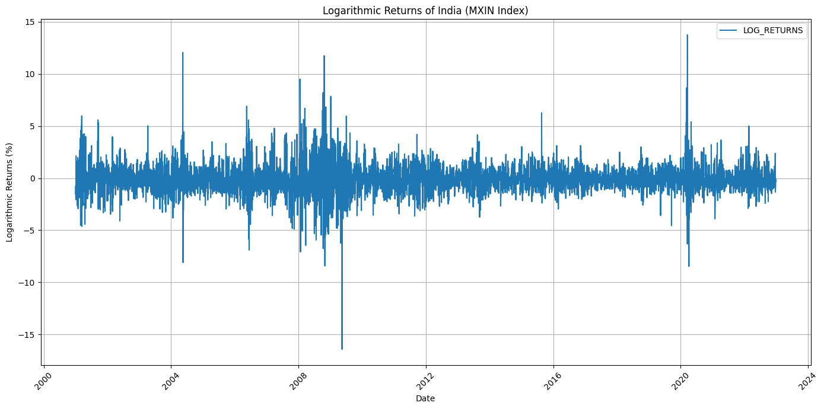

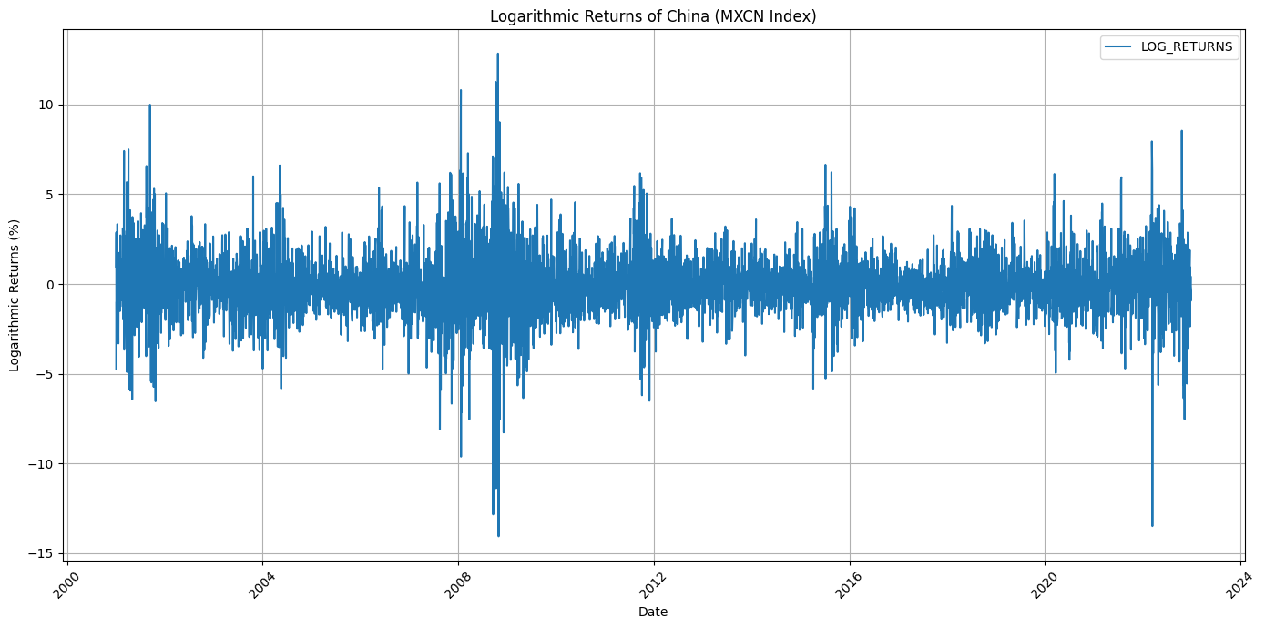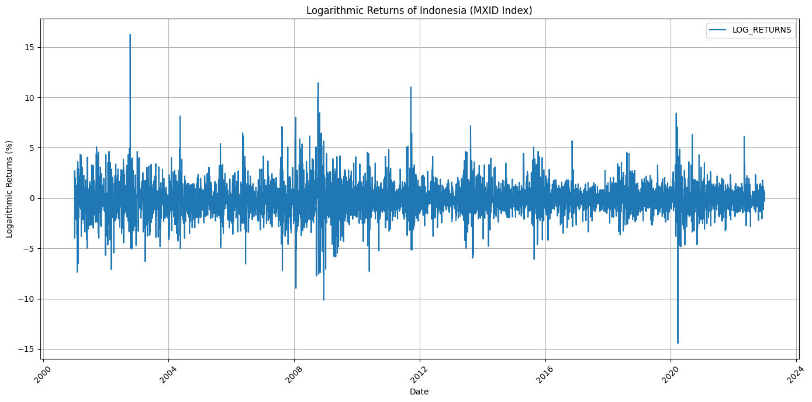

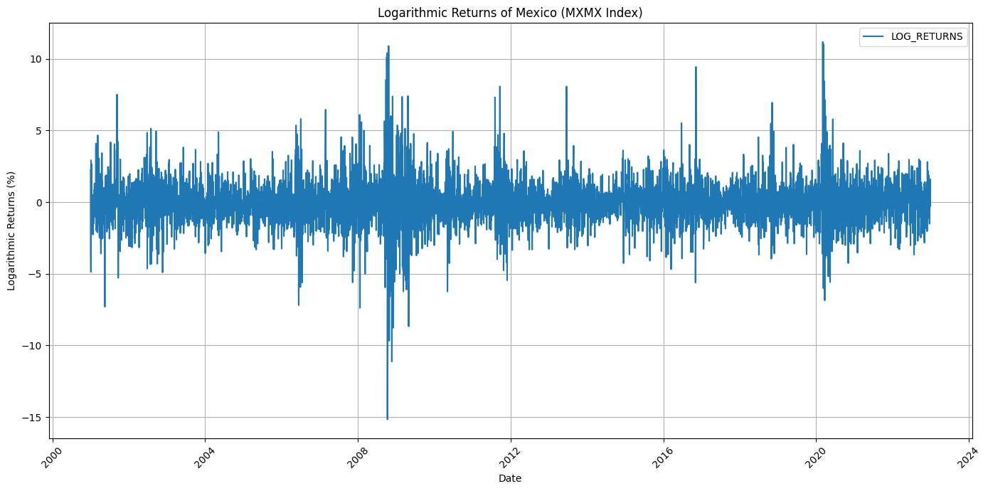

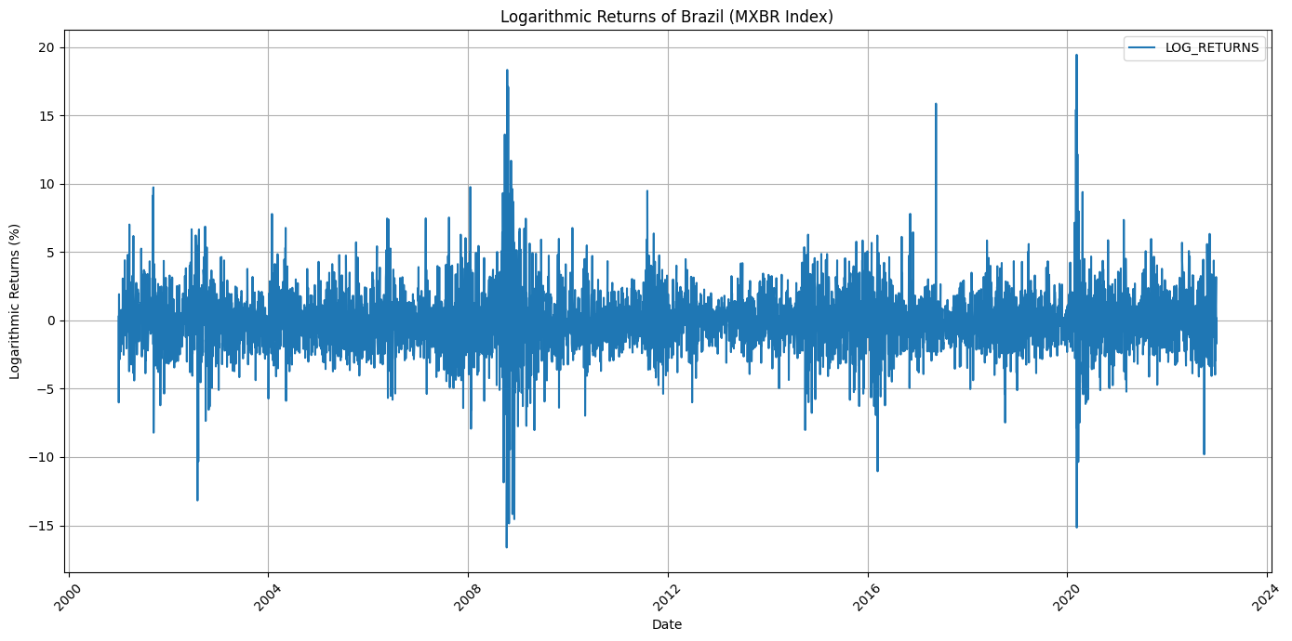

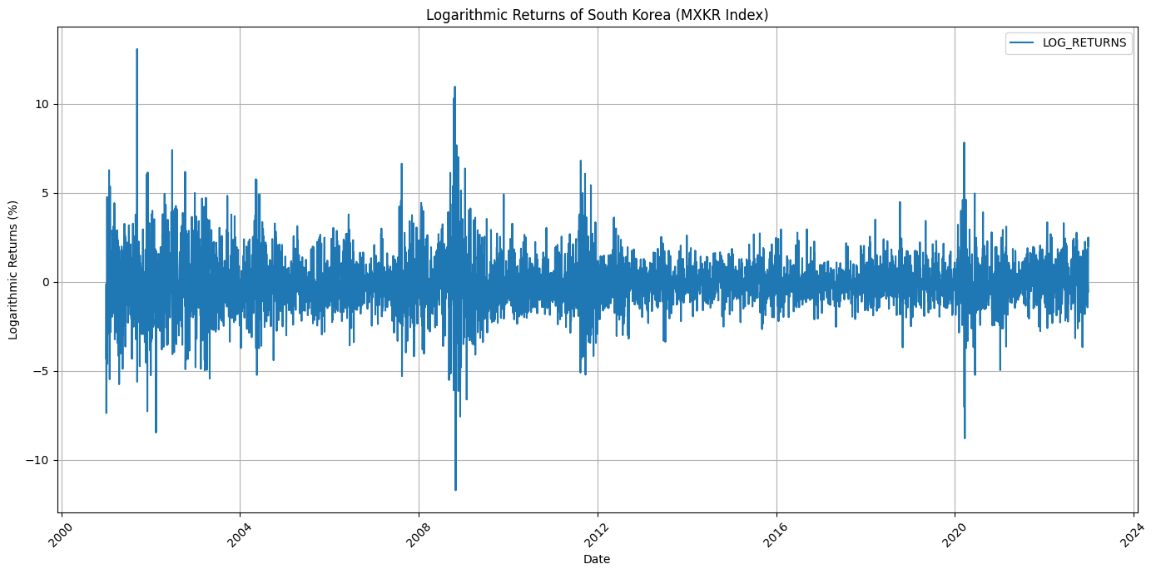

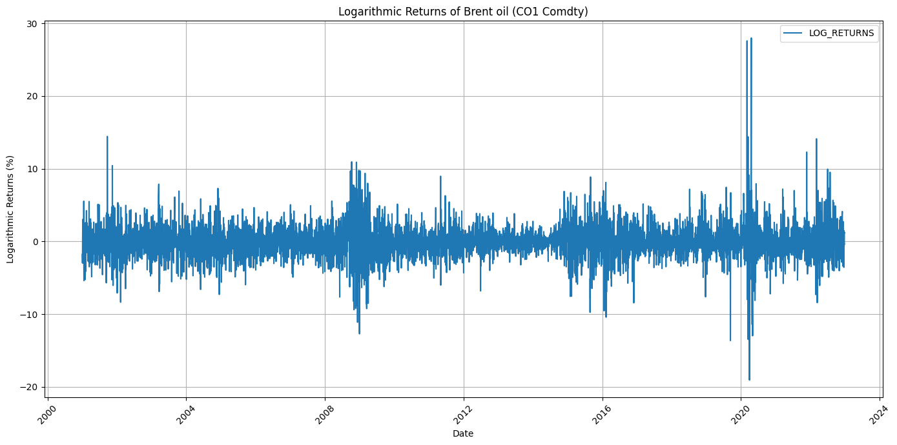

*Fig. 2. Returns of different financial markets*

As seen in table 3, there are kurtosis values and negative skewness for all the financial returns, thus keeping it consistent with the properties of fat tailed, steep peaked and skewed distributions for returns. At the same time, the Jarque-Bera statistics reject the normality of stock returns, the means and medians of returns are close to zero, and there’s high standard deviations in returns, implying high volatility. Finally, we can see in Fig 3. that there is a positive correlation between the returns of Brent Oil and the stock markets.

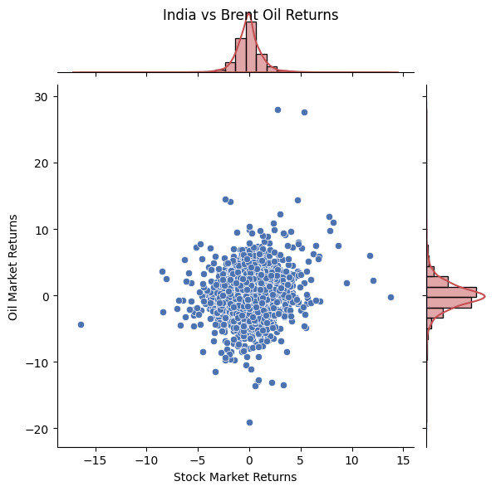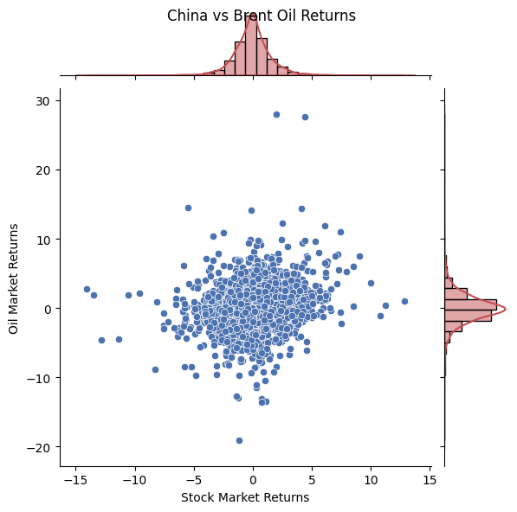

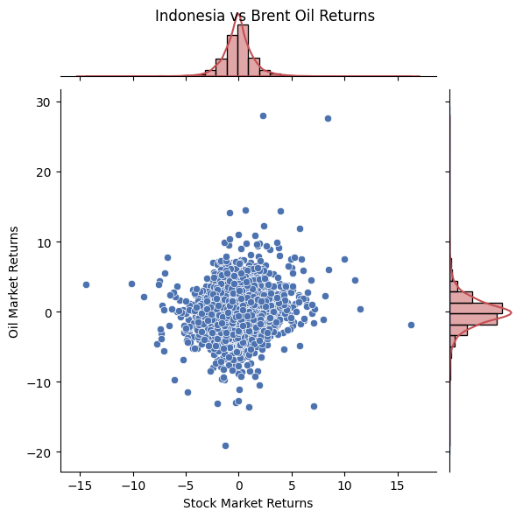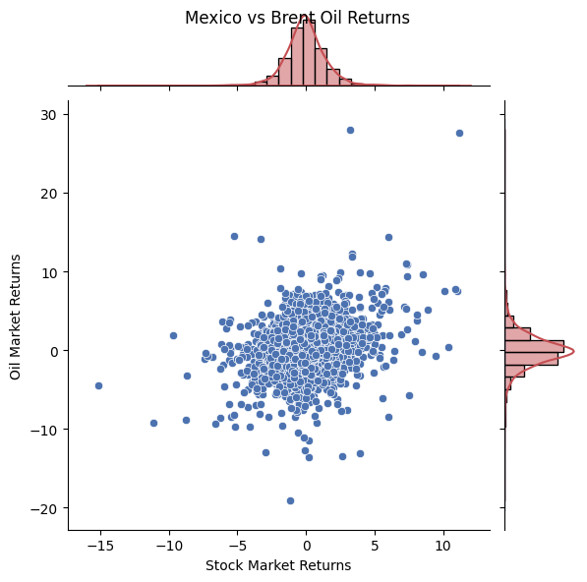

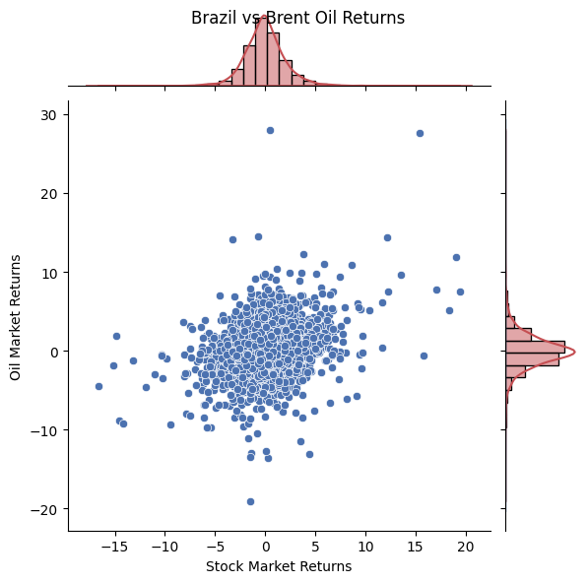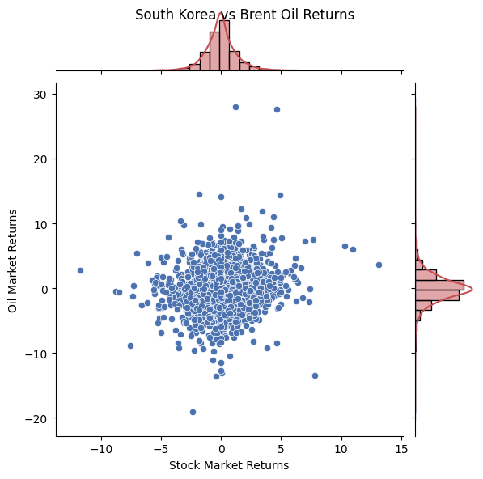

*Figure 3: Scatterplots depicting the relationship between returns in the oil and stock markets.*

*Table 3: Statistical Summary for MSCI Index Returns in Stock and Oil Markets (Descriptive Table)*

|  | mean | max | min | median | std | skewness | kurtosis | q05 | q95 | jarque_bera | brent_corr | ljung_box | arch |
| --- | --- | --- | --- | --- | --- | --- | --- | --- | --- | --- | --- | --- | --- |
| India | -0.043 | 13.74 | -16.421 | -0.037 | 1.371 | 0.406 | 14.593 | -1.958 | 2.022 | (32292.832438699297, 0.0) | 0.155 | (102.53870667357401, 0.0) | (684.4374237140067, 0.0) |
| China | -0.018 | 12.838 | -14.059 | 0 | 1.686 | 0.033 | 9.491 | -2.486 | 2.676 | (10073.625219250529, 0.0) | 0.158 | (80.25228858689364, 0.0) | (1118.5683839252147, 0.0) |
| Brazil | -0.011 | 19.434 | -16.619 | -0.059 | 2.217 | 0.468 | 11.344 | -3.131 | 3.45 | (16854.551858621748, 0.0) | 0.305 | (68.44552102932323, 0.0) | (1470.3725793569363, 0.0) |
| South Korea | -0.029 | 13.091 | -11.722 | 0 | 1.424 | 0.279 | 9.455 | -2.118 | 2.283 | (10036.979160916595, 0.0) | 0.133 | (31.230140651633583, 0.052) | (813.6557424618001, 0.0) |
| Mexico | -0.023 | 11.183 | -15.159 | -0.051 | 1.586 | 0.282 | 9.778 | -2.341 | 2.391 | (11060.192585220986, 0.0) | 0.273 | (96.37611084851379, 0.0) | (1341.1080276692132, 0.0) |
| Indonesia | -0.049 | 16.261 | -14.444 | 0 | 1.565 | 0.304 | 10.775 | -2.354 | 2.393 | (14542.371776422493, 0.0) | 0.121 | (74.05872809103774, 0.0) | (468.8834420147517, 0.0) |
| Brent oil | -0.022 | 27.976 | -19.077 | -0.07 | 2.305 | 0.633 | 14.534 | -3.421 | 3.585 | (32190.194970732507, 0.0) | 1 | (42.97754086819164, 0.002) | (564.7412183573323,  0.0) |

#### *4.2 Propagation of Dynamic Risks from Oil to Stock Markets*

The dynamics of CoVaR and ΔCoVaR for the six stock markets during the analysis period are shown in Figs. 4 and 5 at the 0.95 confidence level. The dynamic CoVaR and ΔCoVaR for each stock market are noticeably different, demonstrating that the influence of extreme risk in the oil market on extreme risk in stock markets varies by country.

Like, let's see the graphs. The trend of risk spillovers to the stock markets in Brazil and Mexico is consistent. Furthermore, it is evident from the sudden shifts in the CoVaR and ΔCoVaR that certain significant risk events, such the global financial crisis in 2008, the European debt crisis in 2010, and the COVID-19 issue in 2020, have an impact. It is clearly evident that the CoVaR and ΔCoVaR for the Indian stock market were extremely large during the global financial crisis and the COVID-19 pandemic.

In particular, the unstable oil market had a significant negative impact on the Russian stock market as a result of the Russia-Ukraine conflict that began in 2014. As a result, in addition to the macroeconomic climate, foreign geopolitical shocks that impact the price of oil also contribute to the stock markets' abrupt up and down swings. The downside spikes are noticeably bigger than the upside, as seen from the plots.

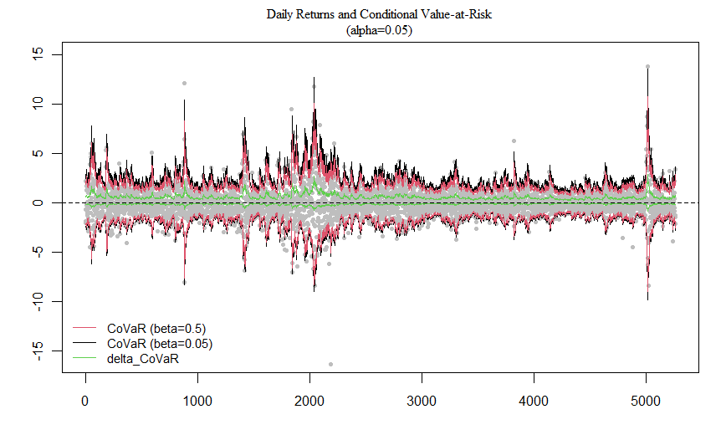

China

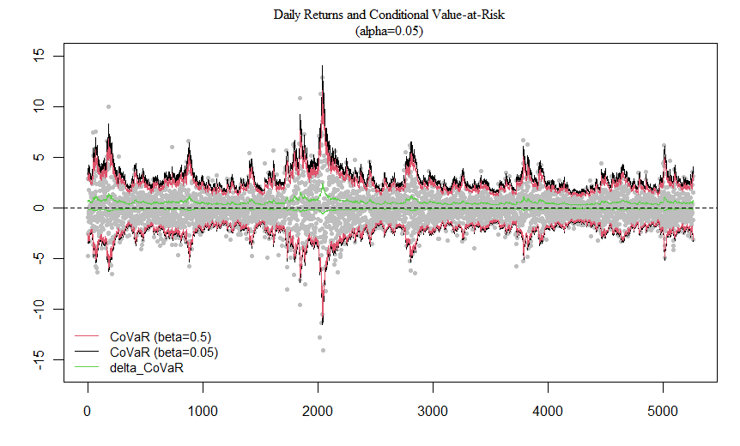

Brazil

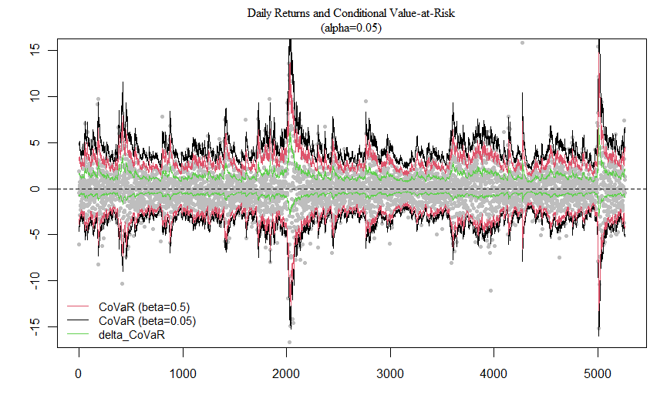

South Korea

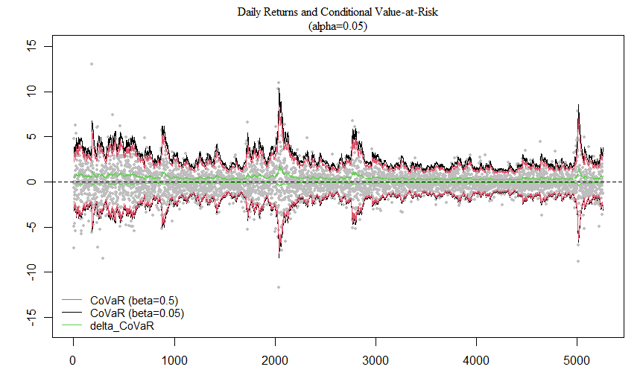

Mexico

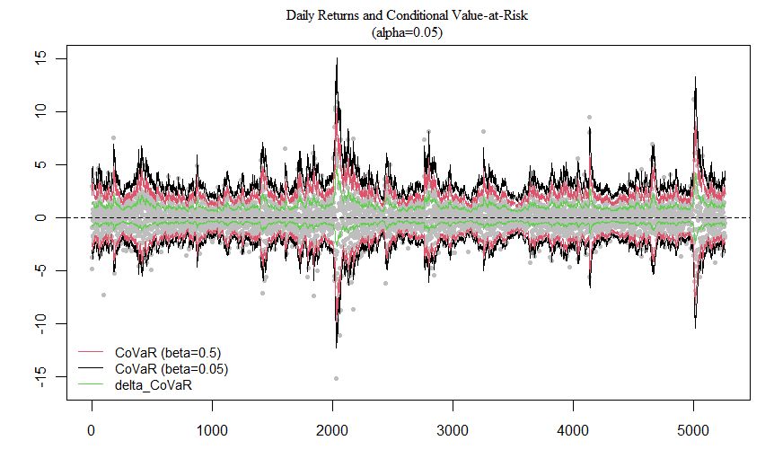

Indonesia

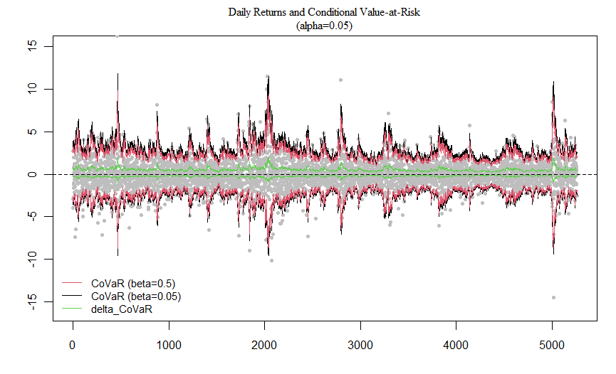

*Fig. 4. Dynamics CoVaR and risk spillovers.(Brent)*

*In each subfigure, the gray points are the stock market returns for ten countries. The red-black lines stand for the CoVaRs of the benchmark state and the distressed state, respectively.*

|  | Brent_CoVaR_Lower | Brent_CoVaR_Upper |
| --- | --- | --- |
| India | -1.676 | 1.774 |
| China | -2.091 | 1.828 |
| Brazil | -2.327 | 2.3 |
| South Korea | -2.194 | 2.19 |
| Mexico | -2.284 | 2.223 |
| Indonesia | -2.197 | 1.718 |

*Table 5: CoVaR Upper Lower values Brent vs Countries*

Fig 5 shows the code output values Brent oil with other countries. The upper and lower values show the deviation due to the risk spillover.

#### *4.3 Results and Inference*

Significance test indicates that the null hypothesis is rejected at 1% significance level.

Hence we can say that the oil market significantly contributes to the stock markets in all the six countries.

Indonesia comes in second place with the mean absolute magnitude of downside risk being the highest for India. Portfolio managers with long holdings will carry the highest risk from the oil market's bearishness, according to the highest downside risk spillover from the oil market to the Indian stock market. This is consistent with the significant tie between India and oil. The bearish oil market has minimal impact on the Mexican stock market, but its negative effects may be quite erratic.

Downside

| COUNTRIES | MEAN | STD DEV | RANK |
| --- | --- | --- | --- |
| India | -1.55348 | 0.09880 | 1 |
| China | -1.42972 | 0.08924 | 4 |
| Brazil | -1.36715 | 0.24856 | 5 |
| South Korea | -1.43353 | 0.07169 | 3 |
| Mexico | -0.95904 | 0.43837 | 6 |
| Indonesia | -1.44179 | 0.12145 | 2 |

*Table 6:Downside risk spillover using absolute means to rank*

The mean absolute value of upside of upside risk is the greatest for China, closely followed by South Korea. The largest upside risk spillover from the oil market to the Chinese stock market indicates that portfolio managers with short positions could suffer the largest risk over the bullish oil market.

Oil has the least amount of risk spillover (upward and downward) on the developing stock markets of Brazil and Mexico. This suggests that when oil prices sharply rise or fall, investing in both stock markets is the least risky.

The Indian and Chinese stock markets for emerging economies exhibit the greatest risk spillovers, both upside and downside, in relation to the price of oil. These findings suggest that country-specific factors influence the spillovers of upside and downside risk, and it is imperative that investors worldwide make use of this knowledge.

Upside

| COUNTRIES | MEAN | STD DEV | RANK |
| --- | --- | --- | --- |
| India | 1.13630 | 0.37435 | 3 |
| China | 1.42644 | 0.25356 | 1 |
| Brazil | 0.74811 | 0.61404 | 4 |
| South Korea | 1.38498 | 0.25935 | 2 |
| Mexico | 0.69614 | 0.66527 | 5 |
| Indonesia | 1.38335 | 0.25723 | 2 |

*Table 7 :Upside risk spillover using absolute means to rank*

Observing the mean absolute values, it is found that the downside risk spillovers are comparatively more than the upside risk spillovers, which is indicative of the fact that oil is an important commodity for the emerging markets.

From the graphs, we can clearly see spikes at 2 different times, one between 2008-2009 period and the other between 2019-2021.

These spikes are from the 2008 Housing crisis ( Economic Depression) and the COVID-19 pandemic. The Russia-Ukraine conflict started in 2014, and turned into a war after 2022. We have considered the period just before 2023, hence the complete effect of it could not be covered.

China, obviously, showed no significant fluctuations during the COVID-19 period. India showed fluctuations due to slightest of turmoils in the oil commodity market. This is because India is heavily dependent on Oil.

Test done using the specifications:

Argument | Value

--------------------------------|--------------------------------

formula | y ~ GumbelModel(x, Δ, μ, σ, τ)

data | Dat

start (Δ) | 1.1257506

start (μ) | -0.1261274

start (σ) | 1.0103893

τ (tau) | [1] 0.05

trace | TRUE

control maxiter | 100

control k | 2

control InitialStepSize | 1

control big | 1e+20

control eps | 1e-07

control beta | 0.97

### 5. CONCLUSION

#### *5.1 Brent Oil vs the Countries*

Based on the MSCI daily data from January 2001 to December 2022, we conducted an empirical study to assess the risk contribution of Brent crude oil to stock markets in six developing countries using the GARCH CQR -based DCoVaR and UCoVaR models. The results show that the stock markets in China and India, as well as Indonesia and India, show the highest levels of spillovers related to downside and upside risks, respectively.

Tian and Ji (2022) propose the GARCH CQR model, which can describe the nonlinearity of the downside tail dependence structure between financial variables, in order to accurately evaluate the spillovers of downside risk. Assessing the upward spillover risk is crucial for international investors who hold short positions.

The Mexican stock market displays the smallest downside and upside risk spillovers for the countries. Asymmetricity of the graphs show that there is a larger downside effect than the upside effect, as it is expected from any “Risky” asset/investment. Moreover, the dynamic risk spillover effects show heterogeneity over time and are comparatively different for each country.

#### *5.2 From Graph*

Oil has been one of the most important commodities across the globe. Its need is of utmost importance to emerging economies. But, the fluctuation in its price has a heavy impact on growing nations and even some of the developed nations. We saw the risk spillover due to this volatility reach the stock indices of the countries affecting firms and companies across different countries.

Political conflicts often are a cause of the commodity disruption. The recent spikes in India, Brazil, Mexico, South Korea and Indonesia are a consequence of the Covid-19 pandemic and the Russia-Ukraine conflict.

A much bigger spike can be seen towards the 2008-2010 period caused by the infamous Economic crisis of 2008.

For investors and businesses, estimating the upside and downside risk spillovers from the commodity market—in this case, oil—to the stock markets is crucial. They ought to be conscious of which country's index is significantly impacted by oil prices and which one isn't. As a result, even in trying times, a position can be taken to reduce risk and maximise returns.

The dynamic risk spillover effects show heterogeneity over time. They are somewhat different for different countries. Thus, investment portfolios can be optimized accordingly.

*5.3 Policy Recommendations*

* **Focus of Supervision:** Rather than concentrating only on the oversight of stock markets with greater market capitalization, like the US stock market, authorities must also regulate the stock markets in Indonesia, South Korea, and India.
* **Investment Opportunity:** It is necessary to highlight the importance of investing in less volatile and comparatively unaffected stock markets like that of Mexico, over the high market cap indices of China and India.
* **Regulations:** Dramatic swings in oil prices have the potential to unleash tremendous volatility in the stock market. Financial regulators should thus keep a careful eye on and efficiently manage the effects of the high level of risk associated with the oil industry. Regulatory bodies can more accurately assess markets under high pressure by using the rating of risk spillovers to the stock markets based on changes in returns from the oil market.
* **Risk Management Strategy:** To mitigate asset losses from oil market risk spillovers, it’s crucial for fund managers and global investors to thoroughly assess risk contagion measurements and adjust their positions accordingly to optimize portfolio strategy. Greater downside risk spillovers from the oil market to the Indian and Indonesian stock markets suggest that portfolio managers with long positions in these markets could face larger risks during bearish oil market periods. To mitigate this, they should consider closing their long positions or allocating proper instruments to hedge the downside risk spillovers, especially during oil market crises.

### 6. APPENDIX

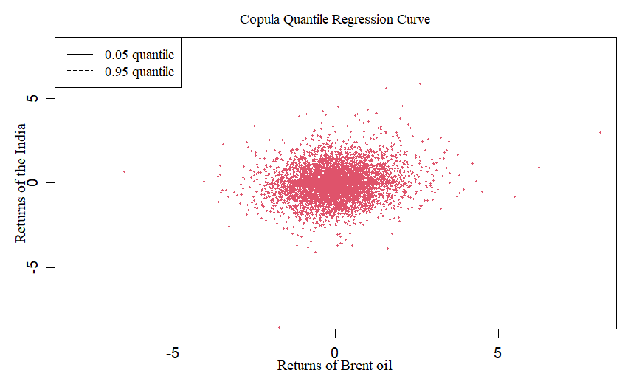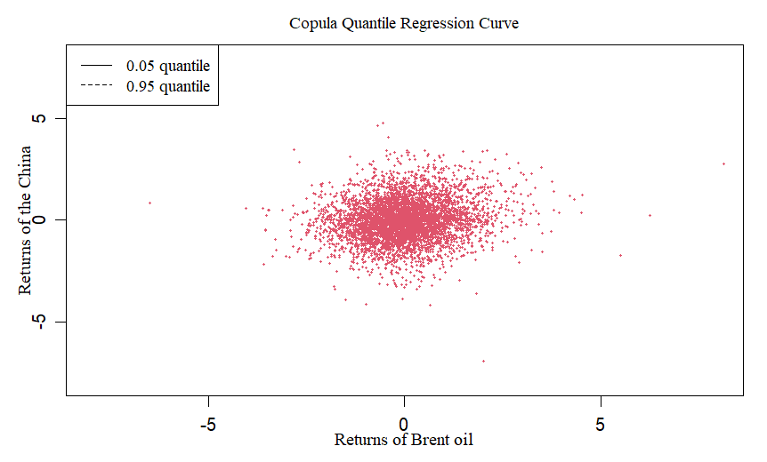

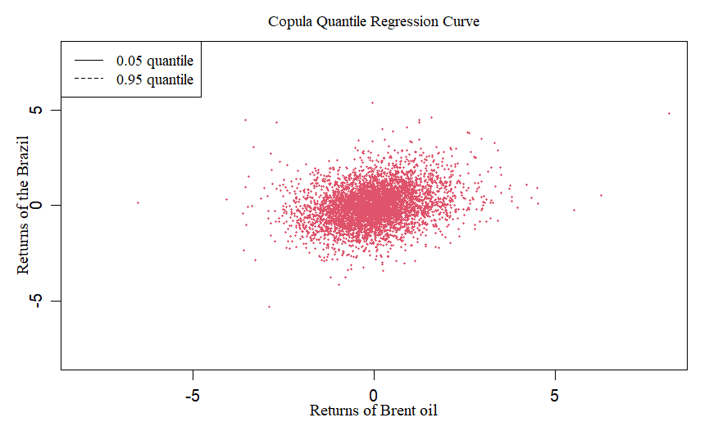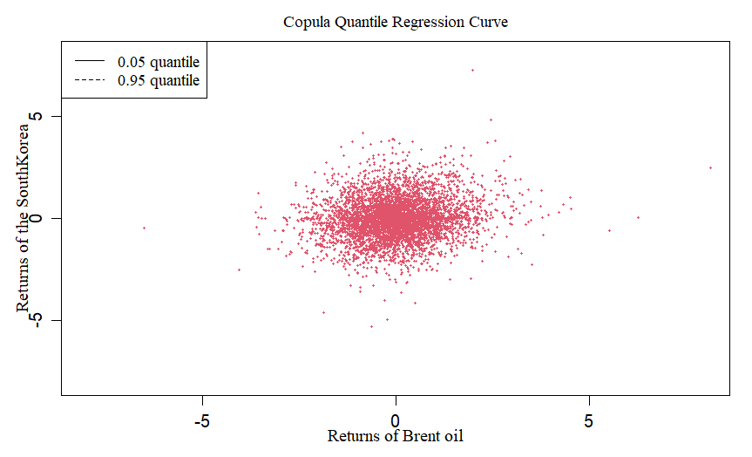

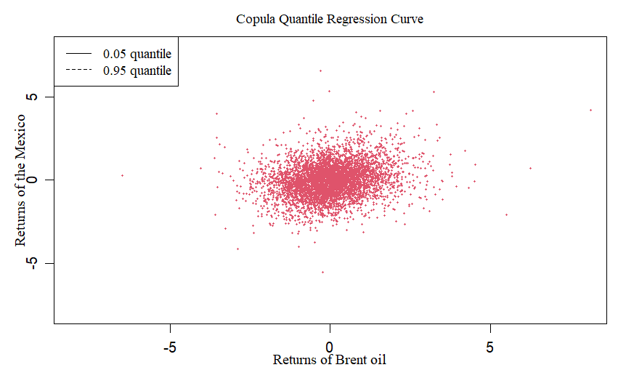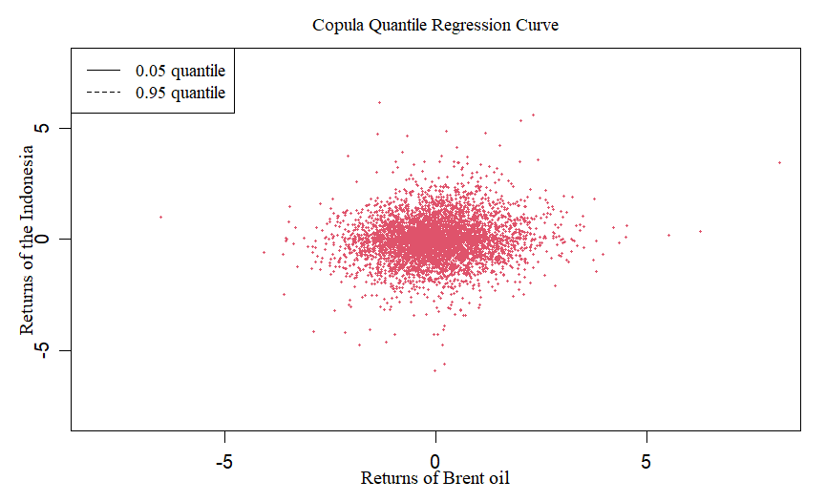

*Fig 5: Gumbel CQR Country-wise for Brent*

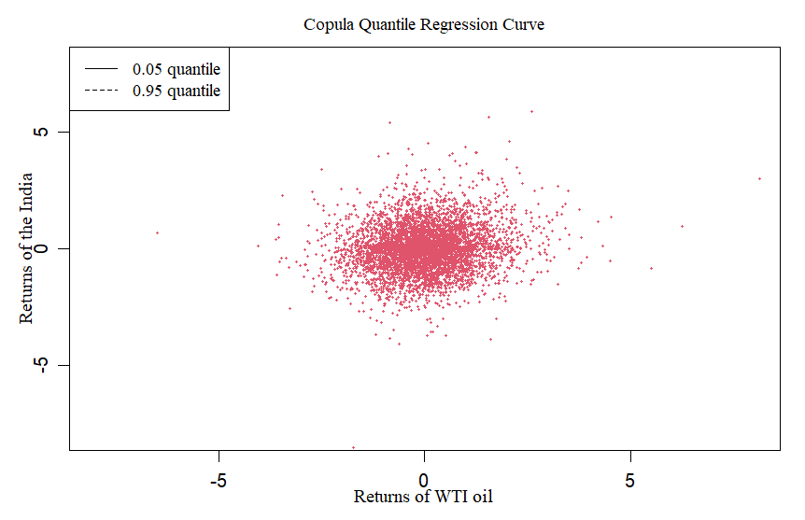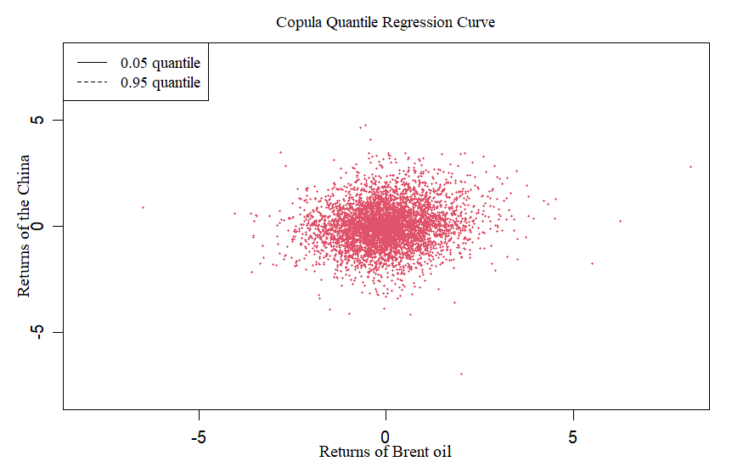

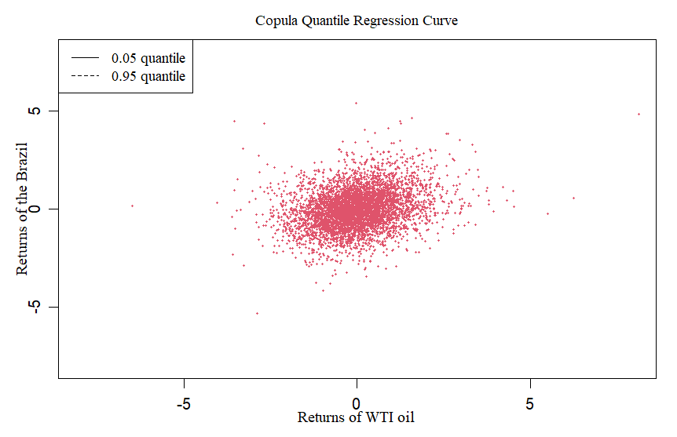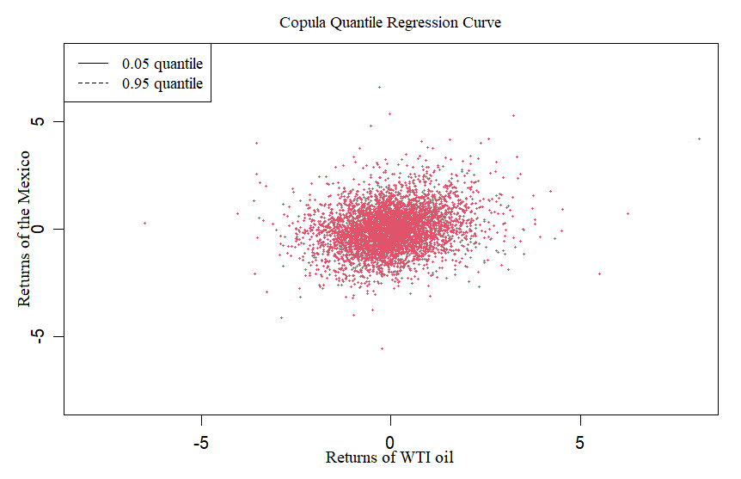

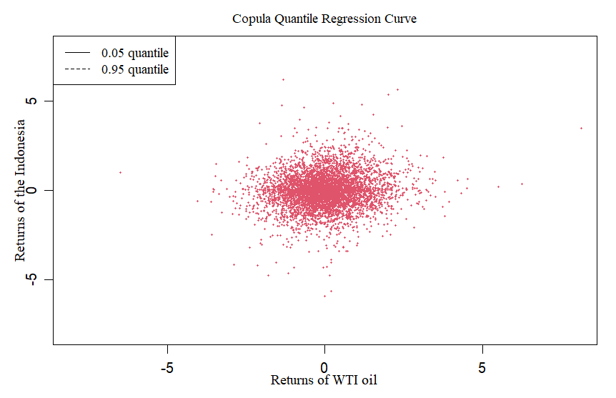

*Fig 6: Gumbel CQR Country-wise for WTI*

### 

### 

### 

### 

### 7. REFERENCES

1.Gong, X.-L., Feng, Y.-K., Liu, J.-M., & Xiong, X. (2023). Study on international energy

market and geopolitical risk contagion based on complex networks.

Resources Policy, 82, 103495.

2. British Petroleum. (2022). Statistical Review of World Energy. BP Global.

3. Khan, M., Khan, M., Kayani, U. N., Mughal, K. S., & Mumtaz, R. (2023). Unveiling

Market Connectedness: Dynamic Returns Spillovers in Asian Emerging Stock

Markets. International Journal of Financial Studies, 11(3), 112.

4. Richard N. Cooper. (n.d.). Retrieved November 24, 2023

5. ‌Rasche, R. H., &amp; Tatom, J. A. (1977). The Effects of the New Energy Regime on

Economic Capacity, Production, and Prices. Review, 59.

6. Bernanke, B. S., Gertler, M., Watson, M., Sims, C. A., &amp; Friedman, B. M. (1997).

Systematic Monetary Policy and the Effects of Oil Price Shocks. Brookings Papers

on Economic Activity, 1997(1), 91.

7. Abbott, Keith. (2007). Employment Relations: Integrating Industrial Relations

and Human Resource Management. Problems and Perspectives in Management.

8. Bernanke, B. (1983). Non-Monetary Effects of the Financial Crisis in the

Propagation of the Great Depression.

9. Tian, M., Alshater, M. M., &amp; Yoon, S. (2022). Dynamic risk spillovers from oil to

stock markets: Fresh evidence from GARCH copula quantile regression-based

CoVaR model. Energy Economics, 115, 106341–106341.

10. ‌JONES, C. M., &amp; KAUL, G. (1996). Oil and the Stock Markets. The Journal of

Finance, 51(2), 463–491.

11. B., A., &amp; Paul, S. (2021). Oil shocks and stock market: Revisiting the dynamics.

Energy Economics, 96, 105111.

12. ‌Barbaglia, L., Croux, C., &amp; Wilms, I. (2020). Volatility spillovers in commodity

markets: A large t-vector autoregressive approach. Energy Economics, 85, 104555.

13. Basher, S. A., &amp; Sadorsky, P. (2006). Oil price risk and emerging stock markets.

Global Finance Journal, 17(2), 224–251.